ANNUAL MEETING
Of
GREAT WITLEY & HILLHAMPTON PARISH
GREAT WITLEY VILLAGE HALL
7.30PM THURSDAY 16TH MAY 2019
Reports will be presented by the following:
- Chairman’s Report
- West Mercia Police Community Support Officer
- District Councillor Paul Cumming
- County Councillor Ken Pollock
- Great Witley Village Hall
- Great Witley Church
- Quarter Green
- Scouts & Cubs
- Guides & Brownies
- Great Witley Primary School
- Neighbourhood Plan Working Party
Following the reports there will be an open forum in which you are welcome to share any views or concerns that you may have with your fellow villagers and put any questions to your Parish Councillors
This year Charlie’s Bar will be available with the first ticketed drink free (wine/beer/soft) and for your entertainment we are very lucky to have Mr Chris Davies, guest speaker, whose talk is entitled:
Art in nature
I’m a Worcestershire born artist and tutor who is now based in Sedgley in the Black Country. My work, which is produced in oils, acrylics, watercolours and inks, explores recurring themes of nature and its place in our rural and urban landscapes. I seek to go beyond a straightforward depiction of a scene or person and instead create a new narrative and emotional response for the viewer. During the presentation, I’ll be talking in more details about my art, explaining my creative process and providing a demonstration of some of my techniques.
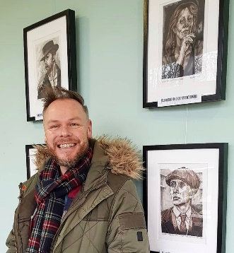
Chris at his recent exhibition in Birmingham which featured his Peaky Blinders Collection

