The Minutes of The Annual Meeting of Great Witley and Hillhampton Parish
Held at the Great Witley Village Hall on Thursday 17th May 2018 at 7.30pm

Present: Chairman Cllr F Chapman (FC), Cllrs G Goodman (GG), R Perkins (RP), C Shaw (CS), C Dermietzel (CD), N Drew (ND), A Symmonds (AS), B Dallow (BD), C Jones (CJ), County Cllr K Pollock (KP) and District Cllr P Cumming (PC)
In Attendance: Clerk, J Evans

1. | Apologies: None.
2. | Progress reports:  - Chairman’s Report: FC attended a meeting regarding the 13 affordable dwellings which are proposed to be built on land off the Stourport Road in an application from 2015. MHDC conceded the need was met but the Inspector allowed the application. Velo went ahead last September without our support. The event has been cancelled for this year and FC thanked KP for his support. In future any Velo event will be re-routed to avoid major disruption to this parish. FC highlighted that we are not opposed to cycling events only the long road closures that surrounded this event. Application for 175 houses was again refused. An appeal has been made and representation has been invited in writing. Speeding concerns remain high on our agenda. The Parish Council do not have any power on this issue, but the A443 Action Group has been formed to pursue traffic calming measures. Data has reported that monitoring and prosecutions make no difference to traffic speeds. Road layouts need to be changed but there is no council budget for this. The Parish Council will invite Rod Reynolds to attend the next Parish Council meeting in July to address these concerns. FC wished to express his thanks to his colleagues for their continued help and support especially through email and thanked Jo Evans for her work as Clerk and Responsible Finance Officer. 30mph stickers were made available at the meeting for use on main road side wheelie bins. Smart Water were represented by the local police and FC outlined how to use it and its benefits in fighting crime.  - West Mercia Police Community Support Officer: In their representative’s absence FC read out the report received from them. This report is attached to these Minutes.  - District Councillor Paul Cumming: PC reported that MHDC are looking to make savings and not make cuts. They are doing this by moving their staff into one building which will prove to be cheaper and provide better communications. Plans for a new reception are on hold due to issues raised by Historic England. Wheelie bin collections have now moved to fortnightly and already an increase in recycling has been seen. Another cost saving method is to work with other councils such as Wychavon. Finally, the Planning Validation system has improved in the last 12 months.  - County Councillor Ken Pollock: New team members have been announced, Paul Robinson is the new Chief Executive, Mike Hudson, Chief Financial Officer and Avril Wilson, Interim Director of Adult Services. Council tax has increased by 1.94%. Most of this money goes on adult social care and care for children; i.e. for people with no money. WCC suffered bankruptcy rumours but these were false. The council is working within its budgets and facts reported were not accurate. KP is very aware of the speeding problems suffered in this parish and those surrounding Great Witley. Recorded accidents are low, but our own perception is that speeds are high. One thought is that the Highways Department could paint 30mph signs on the road. KP will object to any developments. He noted there is a lack of footpaths but said there are no funds for any new ones. KP used the example of the Macefield blocked footpath with was upheld some 13/14 years ago. In the Council’s Travel Plan there is some emphasis on ‘active travel’ – walking and cycling. KP said that Redditch will have to be blocked off for a cycle race. He stressed that Velo was a sportive. He had heard that competitors of Velo thought it was a superb event. KP would like to see such an event again as it is a good showcase for Worcestershire. This year Velo is going to Goodwood and will return to Worcestershire next Spring, the route is yet to be published.  - Great Witley Village Hall: CS delivered his report. Another successful year was reported. They have 3 new members; the bar has been extended and the extension to the footpath with new hand rail has been completed. Film and sound equipment has been purchased through sponsors such as Severn Trent. They now have monthly meetings as the Hall is so busy. Looking ahead, floor maintenance will be carried out. CS was sad to report that a defibrillator has been stolen and an insurance claim has been made.  - Great Witley Church: Please see attached report.  - Quartergreen Sport and Leisure Committee: This facility continues to be very popular and CCTV has now been installed by the changing rooms. It is hoped that the area outside the changing rooms can be improved and also a new, easier to use, tennis net can be purchased.  - Scouts & Cubs: No report submitted.  - Guides & Brownies: No report submitted.  - Great Witley Primary School: Please see attached report.  - Neighbourhood Plan Working Party: FC has nothing to report here as the plan is in “limbo” until we have the outcome to the 175 houses appeal.
GUEST SPEAKER, MR JOHN PAGE, GAVE A VERY INTERSTING AND ENTERTAINING PRESENTATION, THE TITLE OF WHICH WAS ‘LIFE DOESN’T STOP WHEN YOU RETIRE FROM YOUR REGULAR JOB” THIS PASSIONATE, INSPIRATIONAL AND MOTIVATIONAL TALK WAS VERY WELL RECEIVED, AND WE WISH JOHN WELL FOR HIS FUTURE EXPEDITIONS AND TRAVELS!

The meeting closed at 10pm
Signed …………………………………….. Date ……………………………………..
 |  | Chairman

Attached Reports

Chairman’s Report

Report from the Chairman of the GW & HH Parish Council
I became chairman of the PC this time last year and have been on a steep learning curve ever since. The amount of material coming in especially from the County Association of Local Councils is hard to believe. It would involve several days work each week to keep up so I have had to learn to be selective.
There were 4 major issues this year which occupied most of the time of the Council .
1 The Planning Appeal for 13 houses on the north side of Stourport Road. This appeal arose from an application first made as far back as 2015. It was an oral hearing at Malvern which I attended. The applicants wanted to build 13 affordable homes on the site . This was open countryside but by the South Worcestershire Development Plan they would be allowed to build on open countryside if they coulthow that there was an unmet local need for affordable housing. We did not think there was such a need but the Applicants relied on some 20 applications to Housing Trusts for homes in this area. I wanted to check that these applicants had some relationship with Great Witley . It turned out that 2 or 3 did have some relationship —historical or family and this was enough to persuade MHDC to concede that these was a need. The appeal was then inevitably allowed. It was a narrow point but enough to persuade the Inspector.
- The velo Cycle event.
The first event took place in September last year despite our protests about road closures. We gathered together evidence of disruption ,loss of trade , inconvenience etc not only from this Parish but from a wider area and presented it to the County Council and lobbied all of the County Councillors. We were not the only Parish Council doing this but were the most active this side of the river. As you know the event was cancelled for this year and if repeated is likely to take a different route.
- The 175 appeal
Like many of you we made representations that this scheme should not be given Planning permission and were pleased when MHDC refused permission. We waited to see if there was to be an appeal and it came in at the last possible moment. Surprisingly the appeal takes the form of written representations only but this is the appellants choice. It is a cheaper way of proceeding and will avoid a vocal protest from the opposition. MHDC and ourselves are optimistic that the Inspector will uphold the original decision.
4 Speeding.
Parishioners regularly remind us that this is an issue which affects all of us and causes a lot of anger and anxiety. Drivers routinely speed along the Worcester Road and the Stourport Road and with narrow pavements it can be frightening. The Parish Council does not have thee power either to set or enforce speed limits. We have lobbied the County Council, the Safer Roads Partnership and the Police. Two of our Councillors have met with councillors from other Parishes along the A443 who have he same problem. We have had the speed warning signs erected and we are told that we have more speed checks than any other village in the area but it seems to make little difference. Indeed the experts say that monitoring and prosecutions make no difference to speeding so they are not keen to spend more in that way. The only thing that makes a difference is an alteration in the road layout and with budgets very tight we do not expect this to happen.
We have asked the chief of the Safer Roads partnership to attend our September meeting and on Monday next several of us are going to meet a lady from the Worcester County Council Highways department here and hope to impress on her the need for some action.
I would like to publicly thank all my colleagues on the Council for their help and support. Although we only meet 6 times each year we deal with a great deal of business by E-Mail.
Finally I would like to thank Jo ,our clerk, for all the work she puts in. You might find it hard to believe the amount of legal formalities and financial regulations we have to follow and without her prompting we would find this difficult to cope with. We are subject to the same amount of legislation and regulation as a County Council like Worcester, or Town Council like Birmingham and without her help and guidance we would not easily find the bit of importance to us.
Frank Chapman

Police Report

Dear all,
In case I am not able to attend the Parish AGM's I am sending the reports now. I have enclosed a table for ali for au collated crime statistics for the whole area- Some of these figures will relate to serious assaults, domestic assaults and crime and or sexual assaults. Obviously these types of crime are not reported via NHW or Parish reports and so the figures may 'read' higher than you may expect.
As a summary for the year end, shed, garage and outbuildings break ins have slowed down, but have not gone away. I would urge everyone to check that items in these types of buildings are overtly marked, buildings are alarmed and doors made as secure as possible. Items within the homes are marked with a uva product such as Smartwater, and are listed on wwwlmmobilse.com-- This is a free service and greatiy improves the chance of getting back items lost ( eg phone) or stolen. Many Parish's have taken up the offer of the 'bulk buy' purchase of Smartwater to enable all their parishioners to be Smartwtater households, making the Parish 'Smartwatered', with appropriate signage to match.
We are still a team of three, having now been joined by PC Mark Broughton who
Teresa and I are hopeful will be a permanent addition to the team! With the addition of Smart phones, and laptops we are now even more mobile than before, and are able to access our 'workload' as it arrives via the phone. So if you do see us on the phone, we are working! We have been holding surgeries across the area at 4 different locations and have received good feedback from these. Presently these are at Wichenford, Hallow, Martley and Tenbury. Lastly we are looking to carry out more horse tack marking, property marking and also quad and trailers marking events too in the near future, with the next property marking event at Hanley Parish Hall 10 — 1 on April 28th
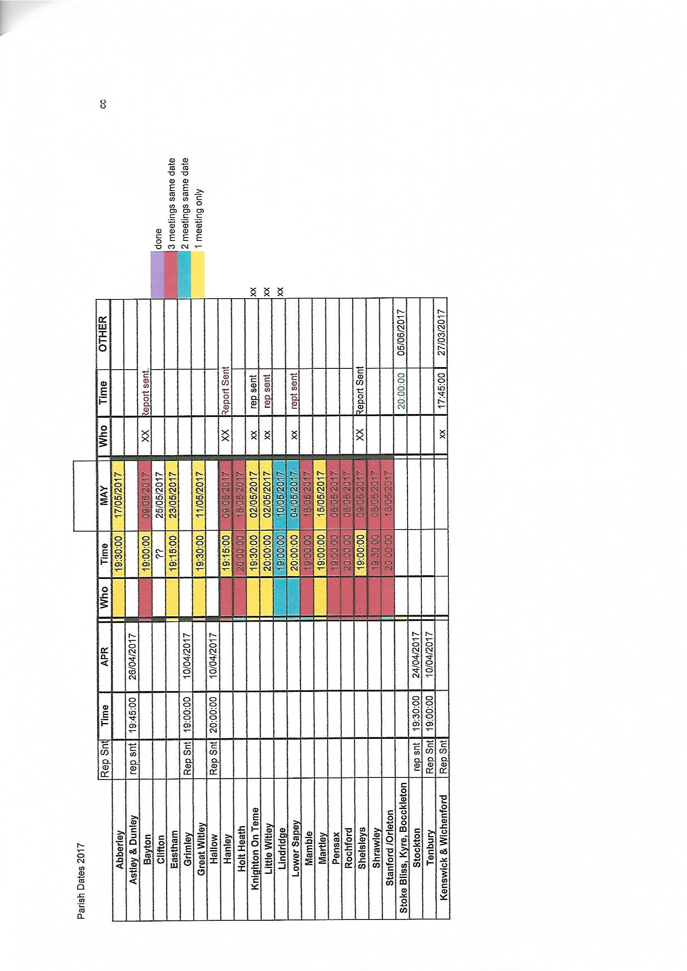

2018 2018 2017 2017 2017 2017 2017 2017 2017 2017 2017 2017 2017 feb jan dec nov oct sep aug jly jun may apr mar feb
Parish | 15 | 3  12  13 | 12  15  13  20 | Il  14 | 10  26 | 10  13 | 16 | 24 | 19  20 | 20 | 14 | 23 | 17
Abberley
Astiey & Dunley
Clifton
Great Witley
Grimley
Hallow
Hanley
Holt Heath
Knighton On Teme
Liadridge
Little Witley
Lover Sapey
Martley
Pensax
Rochford
Shels!eys
Shravhey
Shnford IOrIeton
Stoke Bfiss, Kyre, Bocckleton
Tenbury
Wichenford & Kenswick
 | 54 57 |  | 80 | 75 | 75 | 69 69 79 96 |  |  |  | 78 | 59 | 73 | 71

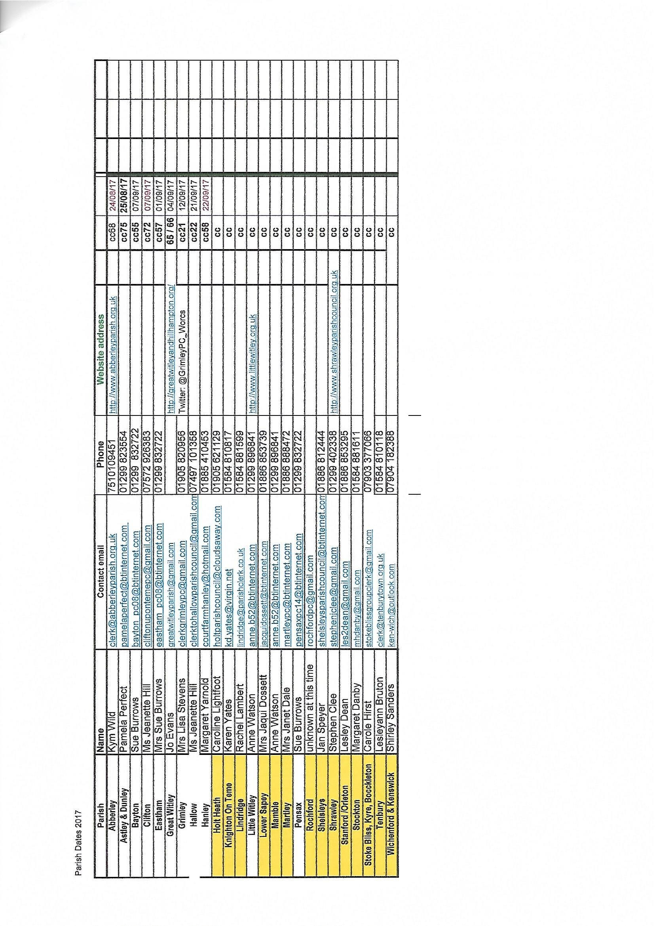
kkkkkkkkkkkkkkkkkkkkkkkkkkkkkkkkkkkkkkkkkkkkkkkkkkkkkkkkkkkkkkkkkkkkkkkkkkkkkkkkkChurch Report

Great Witley Parish Church report to Parish Council
17th May 2018
Great Witley Church and the other churches in the parish, Little Witley and
Shrawley, have continued to develop their ministry as part of the 4 Rivers Benefice and the whole benefice has continued to take part in joint ventures and training.
The Priest in Charge of the whole benefice is Rev.Ted Whittaker who lives in
Great Witley. We have for the time being lost the services of Curate Sally Butcher who was ordained last June but has been seconded to Wyre Forest West. Other ordained ministers, including Robin Walter, assist as required.
We now have a second Church Warden, Mary Bingham, who lives in Great Witley.
Our organist, Phil Johnson, will be leaving shortly as his forthcoming marriage means he is moving from the area.
We have four recitals and six concerts scheduled for this year and details are available on our website.
We are again hosting the concert to raise funds for The Mandalay School for the Deaf and the performers will again be The Choral Scholars of St John's College, Cambridge. This concert last year was a sell out and raised a large amount of money for the charity.
The Art & Craft Exhibition organised by Anne Walter will be held over the August Bank Holiday. It has become a major feature of the church year and continues to raise much needed funds for the churches in the parish.
I must thank all the volunteers who help to keep this beautiful church running both as a place of worship and as a major visitor attraction. We still desperately need more people to help, not just as stewards but also with such things as publicity, the website, cleaning and fundraising. We are hoping that some reordering will take place soon to make the church more accessible to everyone and allow more activities to take place.
The Foley Monument was successfully restored last year and has been much admired by the visitors. We have had several surveys done on various aspects of the building, including the windows and the organ, and these will help us to formulate our restoration plans for the next five years. It is anticipated that we will be applying to the Heritage Lottery Funds for a large grant.
The Tearooms opened during the winter for the first time and despite the dreadful weather this year they are hoping to stay open again next winter.
The access road to the church continues to be a major problem and we would like to thank the Pain family for their efforts to keep it passable. Although we have no frontage onto the drive it is crucial to the running of the church so we are now starting an initiative which, if we can gain the cooperation of all the parties involved, should see a more long term solution to the problem.
Angela Snow
Church Warden
Great Witley Parish Church

School Report

Dear All,
Thank you for inviting the school to submit a report to you for your Annual Meeting, in April. I can hardly believe another year has passed by since my previous update to you all.
The school continues to thrive and increase in size, we have been an academy for almost two years now. We are working very closely as part of the Rivers CE Multi-Academy Trust and feel more than pre-pared for the next OfSTED visit, likely to happen in the summer or autumn term.
The staff team has changed slightly over the last year, with two new Assistant Head Teachers joining me as senior leaders in the school. They have brought enthusiasm and skills which have had an immediate impact on the community. The school remains oversubscribed; we currently have 172 pupils on roll and are running seven classes. The school took delivery of a mobile classroom block in the summer of 2017. Finally enabling us to realise the dream of running a one form entry model. Staff and pupils have enjoyed having the additional space and working on their specific curriculum, rather than delivering a mix of two years in one!
The Multi-Academy Trust is building a brand new 'Free School' in Worcester to help the city meet the needs of a growing population. Great Witley CE Primary School received money to repair the flat roof and we are currently hoping to hear that a second bid to refurbish the main school toilets has been awarded. We have invested in the improved the perimeter fence, replacing an outdated stock fence with a smart green modern version and a code entry gate
We continue to welcome student teachers to the staff team each year. They have supported lessons in Years 6,5,4,1 and in the Reception class. This is great professional development for our staff who act as mentors and it also ensures we are up to date with new ideas from the initial teacher training courses and the University of Worcester.
We continue to enjoy the support of volunteers who give up their time to support the school. We have a number of reading volunteers but can always make use of new skills and talents, perhaps outdoor skills with Forest School or as a gardener. Please contact the school office on (01299)896246 if you wish to volunteer in some way to support the school.
The Annual Harvest Tea party and Christmas Sing-a-long afternoons continue to be popular events within the local community. The children enjoy having such a receptive audience, please look out for an invite nearer the time. We try to coincide with the Harvest service at Great Witley Church, so pencil in the Friday prior to the Harvest Service.
Finally, if you have any further questions or queries regarding the school please feel free to contact me via the school office.
Many thanks,
Mrs Karen Banford Head Teacher
Great Witley C E Primary School - 'Inspiring a life-long love of learning'

