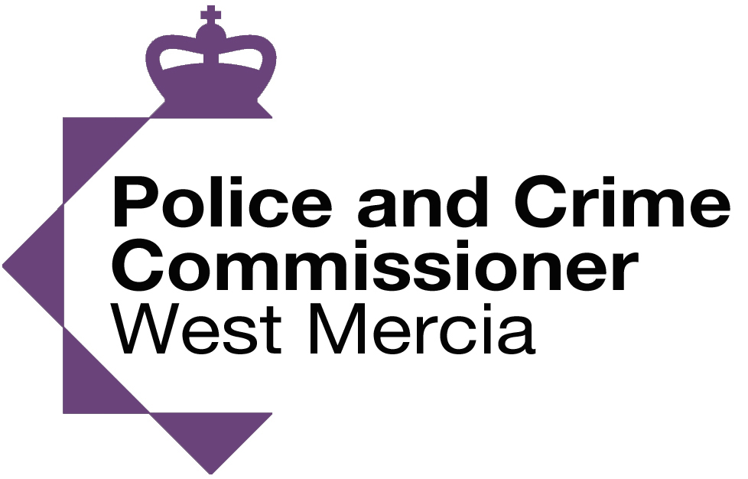


We Don’t Buy Crime
Town’s and Villages

“We Don’t Buy Crime” is a West Mercia Police project that seeks to address the issue of acquisitive crime throughout the force areas of Shropshire, Herefordshire and Worcestershire.
The project is funded by the West Mercia Police and Crime Commissioner
We are aware that acquisitive crime, including burglary, robbery and theft harms our communities. A person’s home and possessions often carry an emotional attachment and when crime interferes with this it can have a long lasting impact on its victims.
West Mercia Police are committed to protecting people from these crimes.
‘We Don’t Buy Crime’ demonstrates this commitment, by taking an innovative approach to reducing and disrupting the market for stolen goods and protecting your home and possessions by making them less attractive to the would-be criminal.
We will be working with second-hand goods retailers to develop a process where every trader in second-hand goods adopts best practice and commits to working with its local police to identify stolen goods and tackle crime. Information about these dealers will be recorded on a unique, ‘We Don’t Buy Crime’, database which will assist in identifying which dealers are at more risk of receiving stolen property. The stores will be displaying the ‘We Don’t Buy Crime’ logo which will be increasing awareness and impact of the project.
A key tool provided by the Portal is that it allows police officers to send stolen property email alerts to stores across the West Mercia force area. We are therefore seeking to work more efficiently and effectively to protect our communities.
We are forming partnerships with local businesses and communities with a common goal of reducing crime. We are working with a local business, SmartWater, to make use of the latest technologies to fight crime, by ensuring that property in homes is marked appropriately and that signage is displayed accordingly.
By working with partners we are looking to property mark as many households as possible to create “We Don’t Buy Crime” towns and villages to significantly reduce the risk of burglaries.
Why use Smartwater to protect homes and possessions?

This approach is supported by a variety of academic research. For example, when interviewing burglars about the best deterrent, Smartwater outscored all other forms of crime deterrent.
Security measure | Score out of 10
SmartWater | 8.3
High visibility police patrols | 7.4
Ink-dye tags | 7.2
Access control systems | 6.9
Window grills | 6.7
CCTV | 6.2
Burglar/intruder alarms | 6.0
Cased merchandise | 5.9
Electronic tagging | 5.0
Security guards/Store detectives | 4.9
Property marking | 4.8
Mirrors | 3.9
Perimeter fencing | 3.8

The above highlights the impact that marking property with Smartwater and displaying the warning signage can have. There are a number of reasons for the above deterrent effect including that property is less attractive, as it carries a greater risk of recovery and difficulty in property disposition.
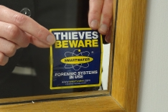

All Police officers will now have a UV light to detect the presence of Smartwater. And can be used when arresting or stopping and searching suspects.
Second Hand stores also have UV lights which they can use to establish whether property is marked and possibly stolen
What is Smartwater?

- Water based solution - Code + Fluorescence + Polymer
- Unique forensic code made of up to 31 Rare Metal Compounds
- Invisible to naked eye - GREEN / YELLOW under UV light
- Can be analysed down to a billionth part, (Pin Head)

Smartwater comes in small container with an applicator brush. Only a small amount of clear liquid needs to be applied to an item and left to dry and then the property is marked. Each bottle of Smartwater is unique which enables the police/ Smartwater to identify the owner of property and therefore return it if stolen, link it to any associated crime and prosecute offenders.

What is a We Don’t Buy Crime Town?

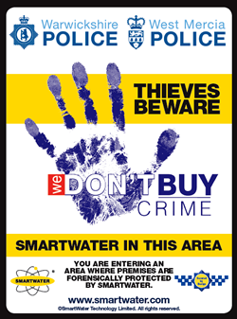
“We Don’t Buy Crime” towns and villages are where every residential property has the opportunity to mark their possessions free of charge with Smartwater and street signage is put up (large warning signs at the key entry and exit routes and smaller repeater signage throughout the Town). The purpose of this is to let any would-be criminal know that if they commit crime they are likely to a) get caught and b) not be able to profit from their crime i.e. second-hand shops and the wider public won’t buy stolen property.

Cleobury Mortimer has become the first “We Don't Buy Crime” Town where over the space of two weeks 1,200 homes have been protected with Smartwater. This was only made possible by working in partnership with local people to achieve a shared goal of protecting the community from harm.

In the short period of time that Cleobury Mortimer has been a We Don’t Buy Crime Town the Parish Council have been inundated with messages of thanks. Many people have stated that they felt the Parish Council in partnership with the Police had made a real difference in making the town safer and even enhancing community spirit.

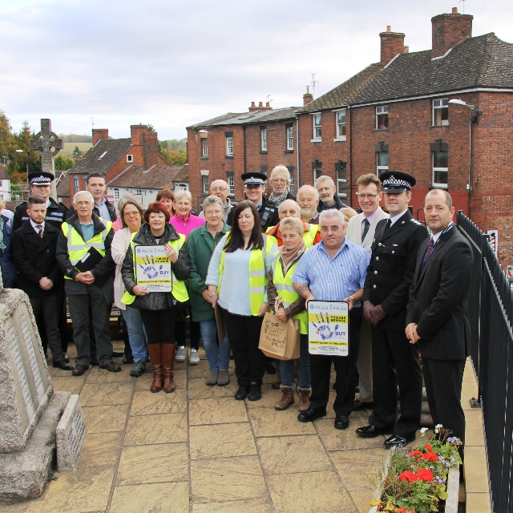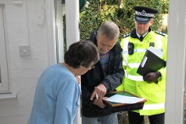
The Launch of Cleobury Mortimer Local Volunteers and the police
as a We Don’t Buy Crime Town conducting joint visits to residents

Interim Results

Cleobury Mortimer
Cleobury Mortimer became a We Don’t Buy Crime Village in November 2015 following recording19 domestic burglaries in a previous 18 month period. Since taking up this initiative the town has recorded 1 domestic burglary(April 2017)
This means that 18 householders have not suffered the trauma of a burglary

Rock
Rock became a We Don’t Buy Crime Village in December 2016. Rock recorded 12 domestic burglaries in a previous 12 month period. Since taking up this initiative the town has recorded 2 domestic burglaries. Both of these addresses have not registered has having Smartwater
This means that 10 householders have not suffered the trauma of a burglary

Leegomery
Leegomery is an area of Telford that became a We Don’t Buy Crime area in July 2016
In the previous 10 month period this area recorded 46 domestic burglaries.
Since taking up this initiative the area has recorded 23 domestic burglaries
This equates to a 50% reduction and means that 23 householders have not suffered the trauma of a burglary

Does this particular approach work elsewhere?

A similar scheme adopted elsewhere identified the following benefits:

- A reduction in burglary by over 80%
- A significant reduction in both robbery other criminal offences
- Analysis evidenced that crime was not displaced and that a diffusion of benefits was found out to 750M from the areas using Smartwater
- Survey sent 6 months after distribution found more than half of respondents reporting feeling safer as a result of their property being treated with Smartwater.

We believe that by creating a “We Don’t Buy Crime” town/village, we will be able to significantly reduce not only acquisitive crime but also the fear of crime.

Potential Cost of Property Marking in your Community

The cost involved in implementing this scheme includes the property marking kits (offered at a reduced rate agreed as part of ‘We Don’t Buy Crime’) at £8.90 and the associated signage. In areas where housing associations own properties they have agreed to fund the marking of their homes and as a number of homes are vacant or already have Smartwater then these can be discounted.

Based on our previous experience we would recommend that those interested in adopting this initiative make their cost prediction on approximately 75% of the homes in the area will be marked.

West Mercia Police would also fund many hundreds of hours of additional police time to coordinate the role out of the project. We would seek to utilise local volunteers, special constables and Police Cadets, getting the community involved. This approach has worked incredibly well in all the areas so far and was identified to have brought the area together and enhanced the sense of community.

West Mercia Police would also fund covert activity utilising Smartwater technology. For example, when the Town of Ludlow suffered from a series of commercial burglaries the offenders were caught within days of the deployment of covert Smartwater technology (see BBC new report: http://www.bbc.co.uk/news/uk-england-shropshire-35299940 ).

We would also be utilising the expertise of Warwick University who are evaluating and supporting ‘We Don’t Buy Crime’ having raised over £30,000 of academic funding.

This will, hopefully, not only provide your community with information with regards to crime reduction but also provide information with regard to the fear of crime and general levels of public satisfaction in the community.

Potential Savings

With reducing crime can come some significant savings for those in your communities. By reducing crime rates the cost of home and car insurance can fall significantly. Not only this but many members of the public have either no insurance or insurance excesses that they have to pay when they are victims of crime By preventing the crime in the first place we can save members of the community significant amounts of money and the distress of becoming a victim of crime. Most importantly we believe we can work together to make your community an even more desirable place to live.

